**SQL Databases Disaster Recovery Run Book**

**Objective**

This document is part of the ARC run book for restoring ODSPROD and MASPROD databases

And all related objects

**Pre-Restore requirements**

SQL is installed and patches to the correct level on the following 2 servers

Server names**: MASPROD -- WP1MASINST01**

**ODSPROD --- WP1ODSINST01**

**SQL Availability Groups setup**

1. Open SQL Server Management Studio and connect to the SQL Server instance.
2. Expand the Always On High Availability folder in the Object Explorer.
3. Right-click on the Availability Groups folder and select the New Availability Group Wizard... option launching the New Availability Group Wizard.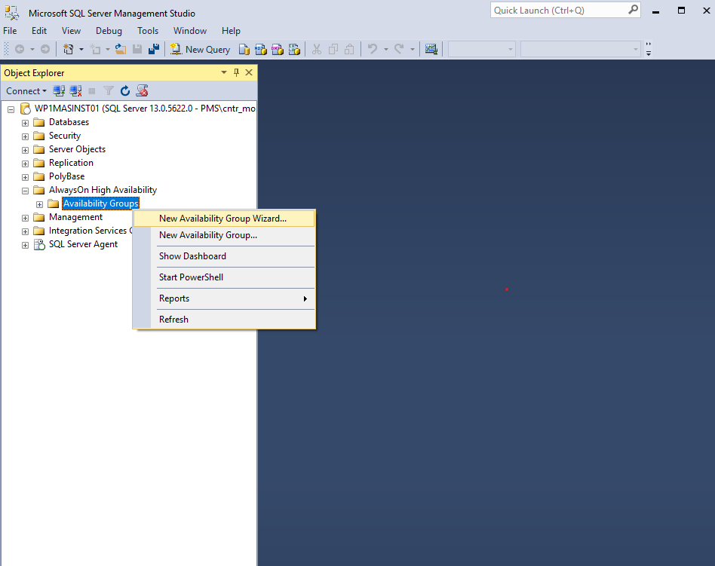
4. Click Next on the Introduction page.
5. Enter the name of the Availability Group in the Availability group name: field and click Next.  
   1. Select the checkbox beside the database to be included in the Availability Group within the Select Databases page.  
         
      *NOTE:* The selected databases need to be in a Full Recovery model prior to joining them in the Availability Group.
   2. Click Next.
   3. Under the Replicas tab within the Specify Replicas page, click Add Replicas and connect to the other SQL Server instances previously joined as nodes with the Windows Server Failover Cluster and configure the following options:  
         
      - Automatic Failover (Up to 2):  Checked  
      - Synchronous Commit (Up to 3): Checked  
      - Readable Secondary: No
6. Select the Create an availability group listener option within the Listener tab and enter the following details:   
      
   - Listener DNS name: Name that will be used in the application connection string  
     
       
   Click Add... once completed and provide the required IP Address.
7. Enter the preferred virtual IP address in the IPv4 Address field within the Add IP Address dialog box and click OK > Next.
8. Select the Join only option within the Select Initial Data Synchronization page.
9. Click Next.
10. Verify all validation checks are successful in the Validation page and click Next.
11. Verify all configuration settings and click Finish in the Summary page.
12. Verify all task have been completed successfully in the Results page.

**SQL Script**

CREATE AVAILABILITY GROUP MASPROD

WITH (

DTC_SUPPORT = PER_DB

)

FOR DATABASE Vertex, VertexReturns

REPLICA ON

‘WP1MASINST02’ WITH (

ENDPOINT_URL = ‘TCP://WP1MASINST02.corp.brinkshome.com:5022’,

AVAILABILITY_MODE = SYNCHRONOUS_COMMIT,

FAILOVER_MODE = AUTOMATIC

),

‘WP1MASINST01’ WITH (

ENDPOINT_URL = ‘TCP://WP1MASINST01.corp.brinkshome.com:5022’,

AVAILABILITY_MODE = SYNCHRONOUS_COMMIT,

FAILOVER_MODE = AUTOMATIC

),

‘VV1MASINST01’ WITH (

ENDPOINT_URL = ‘TCP://VV1MASINST01.corp.brinkshome.com:5022’,

AVAILABILITY_MODE = ASYNCHRONOUS_COMMIT,

FAILOVER_MODE = MANUAL

),

‘VV1MASINST02’ WITH (

ENDPOINT_URL = ‘TCP://VV1MASINST02.corp.brinkshome.com:5022’,

AVAILABILITY_MODE = ASYNCHRONOUS_COMMIT,

FAILOVER_MODE = MANUAL

),

‘WP1ODSINST01’ WITH (

ENDPOINT_URL = ‘TCP://WP1ODSINST01.corp.brinkshome.com:5022’,

AVAILABILITY_MODE = ASYNCHRONOUS_COMMIT,

FAILOVER_MODE = MANUAL

),

‘VV1ODSINST01’ WITH (

ENDPOINT_URL = ‘TCP://VV1ODSINST01.corp.brinkshome.com:5022’,

AVAILABILITY_MODE = ASYNCHRONOUS_COMMIT,

FAILOVER_MODE = MANUAL

)

**Adding a replica to the AG**

* In SQL Server Management Studio, connect to WP1MASINST01 which is our primary replica. Expand the "Always on High Availability" folder followed by "Availability Groups" folder and then Availability Group name MASPROD. You can see three subfolders Availability Replicas, Availability Databases and Availability Group Listeners. Right click on "Availability Replicas" and choose "Add Replica..." as shown in below screenshot

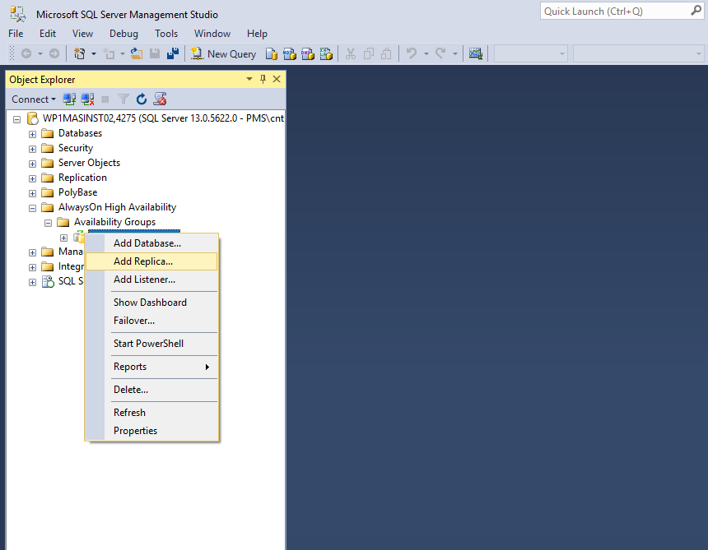

* A new window named "Add Replica to Availability Group - MASPROD" will appear to proceed with the remaining steps. Click on the Next button to go to the next window

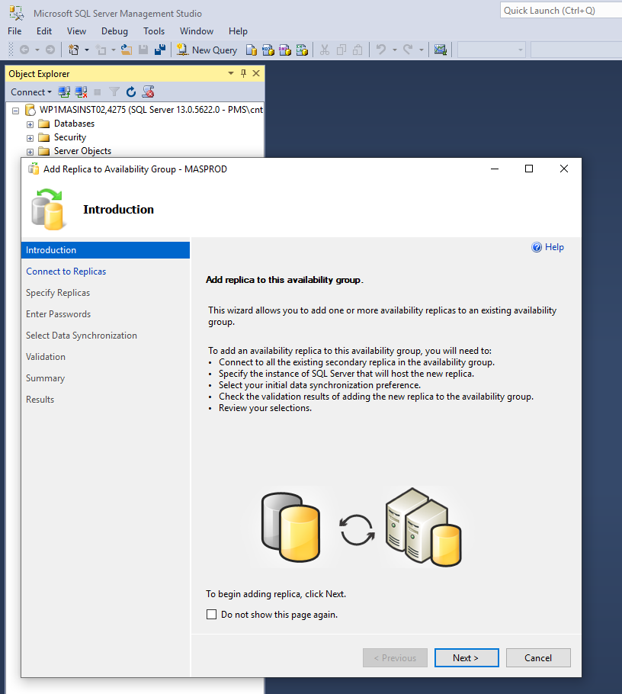

* On the next window, you will be asked to connect to existing secondary replicas, If any. If not go Next

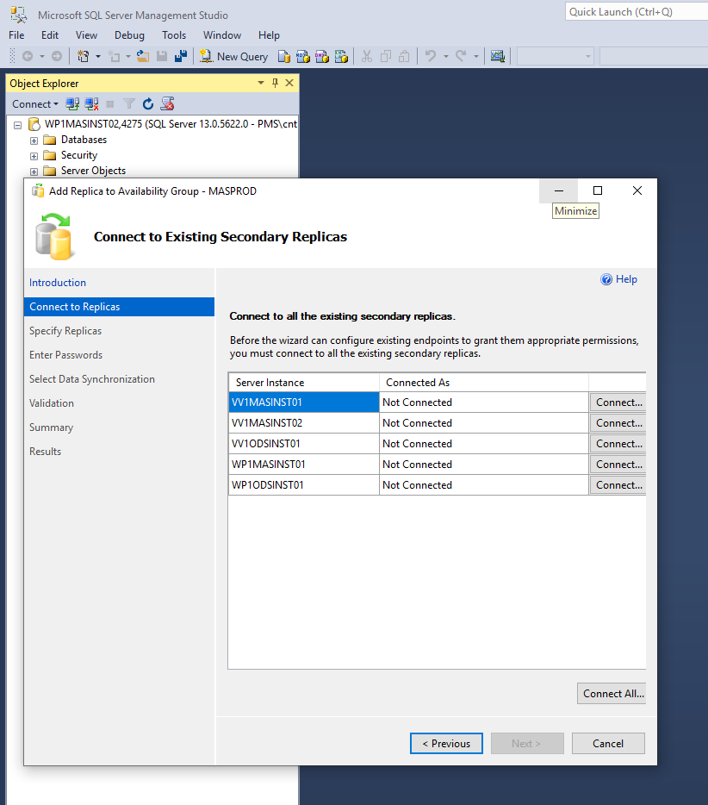

* Now we need to enter the details of target DR replica which needs to be added to the Availability Group MASPROD. Click on the "Add Replica..." button to connect to the target DR replica WP1MASINST01.
* Enter the connection details and click on the Connect button to make a connection.
* Once our target DR replica is connected, you will see it. Earlier there was only one replica now there are two. We will use the same listener which was configured earlier for this configuration. You just need to add a virtual IP for this new replica as it belongs to a different subnet. So click on the "Listener" tab and then click on the "Add" button to enter the virtual IP for the existing listener. Now click on the Next button to proceed to the data synchronization page.
* we will choose the "Join Only" option on page and click Next to proceed.
* **Step 9:** A validation process will run to check the settings.
* Now click Next to go to the final page which is the summary page where you can recheck all of the details. Then click Finish to complete this configuration.
* **Step 10:** When the "Add Replica to Availability Group" wizard runs you will get a summary of all the rules.

## **Validate the AlwaysOn Availability Group in SSMS**

* Once the above wizard finishes successfully, we can validate the AlwaysOn Availability Group in SSMS. Expand the "AlwaysOn High Availability" folder followed by "Availability Groups" and then MASPROD. Expand the subfolder Availability Replicas to see newly added secondary replica WP1MASINST01.
* We can also see the dashboard report of this Availability Group.

**Add a Database to a Secondary replica SQL Server Availability Group Using T-SQL**

### Step 1. On the primary node, add the database to the availability group

USE MASTER;

GO

ALTER AVAILABILITY GROUP [AGNAME] ADD DATABASE [DBNAME];

GO

### Step 2: Perform a full backup of the database on the primary node/replica

You can easily do this using the [SSMS database backup wizard](https://docs.microsoft.com/en-us/sql/relational-databases/backup-restore/create-a-full-database-backup-sql-server?view=sql-server-2017) or with a T-SQL script.

Here’s a simple example below:

BACKUP DATABASE [DBName] TO DISK = N’Path_to_Store_Backup_File\BackupFileName.bak’;

GO

### Step 3: Restore the full database backup on the secondary node along with specifying the “WITH NORECOVERY” option

The [NORECOVERY](https://docs.microsoft.com/en-us/sql/t-sql/statements/restore-statements-transact-sql?view=sql-server-2017) option specifies that a rollback of the database will not take place, thus allowing to restore even more records.

***Note:****You must be very careful when restoring databases. For the context of this article, first you need to make sure that the same database does not exist on the secondary node, prior to run the above-mentioned restore operation.*

You can restore the database using the [SSMS restore database wizard](https://docs.microsoft.com/en-us/sql/relational-databases/backup-restore/restore-a-database-backup-using-ssms?view=sql-server-2017), along with specifying the NORECOVERY option or use a T-SQL statement.

Example:

RESTORE DATABASE [DBName]

FROM DISK = N’Path_Database_Backup_File_Stored\BackupFileName.bak’

WITH NORECOVERY;

GO

### Step 4: Perform a transaction log backup of the database on the primary node/replica

The next step is to go back again on the primary node/replica and perform a transaction log backup of the database.

Again, you can do this using the SSMS backup database wizard or using a T-SQL statement.

Example:

BACKUP LOG [DBName] TO DISK = N’Path_to_Store_Log_Backup_File\LogBackupFileName.bak’;

GO

### Step 5: Restore the log backup on the secondary node along with specifying the option “WITH NORECOVERY”

The next step is to restore the log backup on the secondary node, on the previously restored database (see Step 3), again with the “NORECOVERY” option.

If you prefer doing this using T-SQL instead of the SSMS restore database wizard, below you can find an example of how the T-SQL script looks like.

Example:

RESTORE LOG [DBName] FROM DISK = N’Path_Log_Backup_File_Stored\LogBackupFileName.bak’ WITH NORECOVERY;

GO

### Step 6: On the secondary node, add the database to the availability group by altering it

The final step is on the secondary node to add the database to the availability group by using the ALTER command.

Here’s an example of the T-SQL script:

USE MASTER;

GO

ALTER DATABASE [DBNAME] SET HADR AVAILABILITY GROUP = [AGNAME];

GO

### Step 7: Confirm that all AG replicas are synchronized

It goes without saying that after all the above, you need to verify that all database replicas in the availability group are synchronized. You can do this via SSMS, by right clicking on the availability group under “Always on High Availability” and selecting “Show Dashboard”. There, you can see if everything is OK. If it is all **green**, and you see the wording “no data loss” then all is good.

**MAS Databases**

1. Restore the MAS SQL Servers first of the MAS servers.

Server names**: MASPROD -- WP1MASINST01**

**ODSPROD --- WP1ODSINST01**

* 1. Once the server team complete the server build DBA will install SQL and configure the AG . We need to make sure that these two servers are the only ones in the AG and Cluster, or we could have issues
  2. The SQL backups and the scripts for post restore are stored in the following locations:
     1. Location of backups
        1. **ODSPROD** \\wp1sqlbk03\d$\ODSPROD\Backup

* + - 1. **MASPROD**  \\wp1sqlbk04\d$\MASPROD\Backup Graphical user interface, text, application

         Description automatically generated
    1. Location of scripts -run all scripts the folders in the order below
       1. \\filera\accdb\DBA\Scripts\ARC_Runbook
          1. Users logins
          2. Users permissions
          3. Jobs
  1. **Restore of the DBs back to their respective drives.** Use

Follow the screenshots to choose the backup and restore each Database:

**Right click the database name—tasks---restore---database**

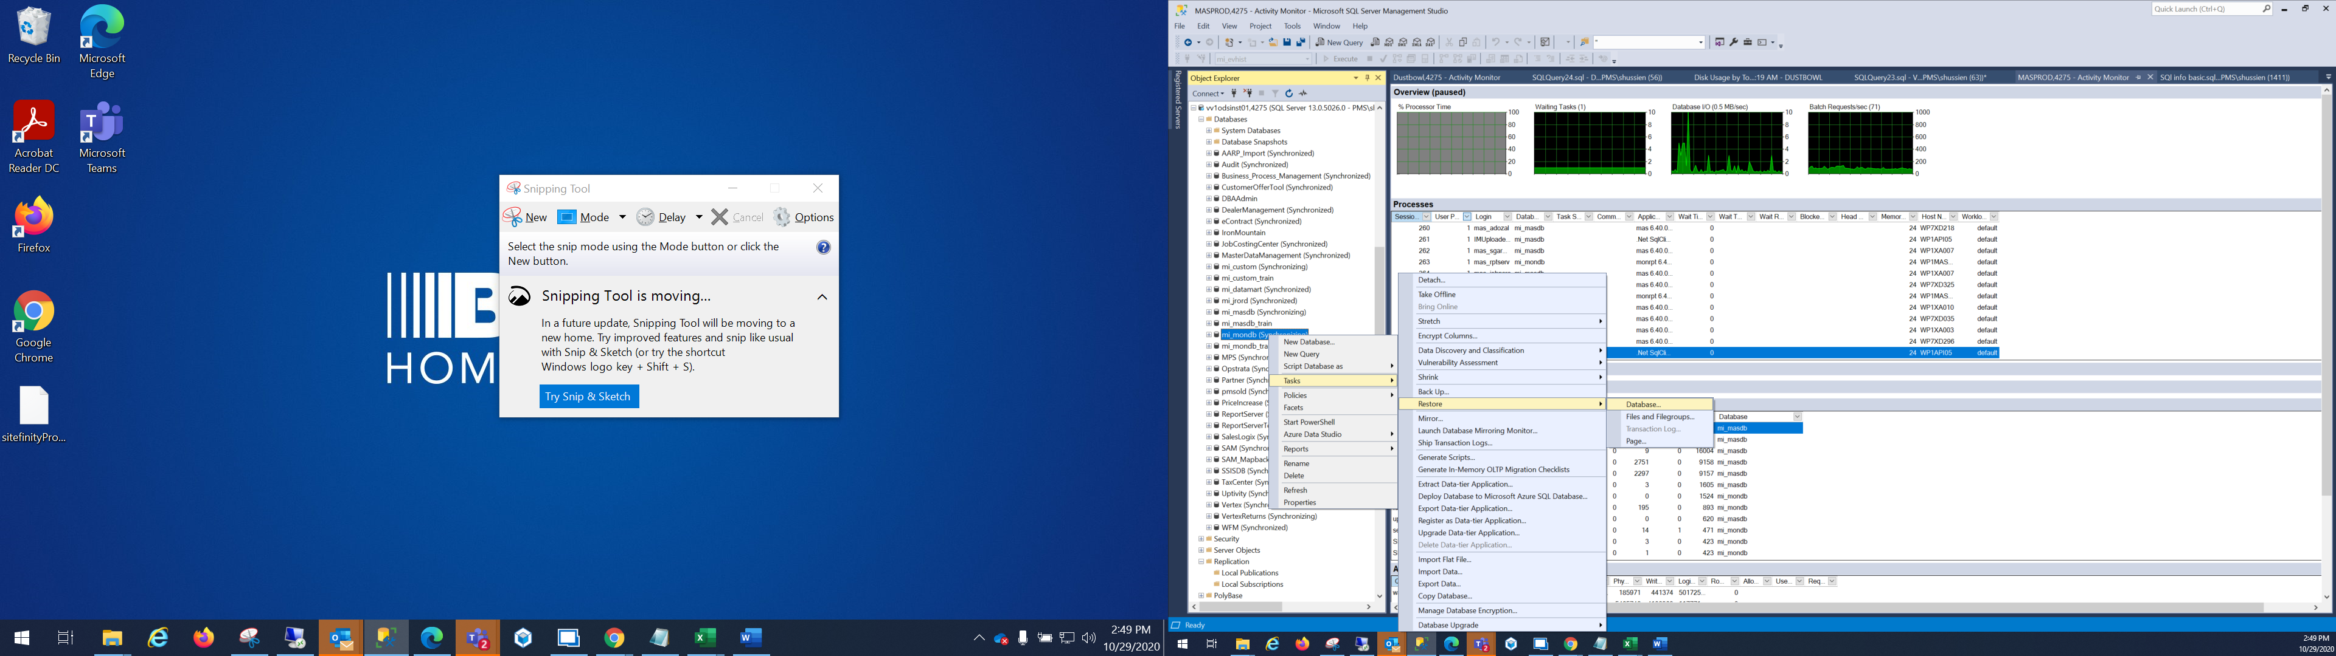

* 1. **ODSPROD** -- Using the backups from step b:i:1 - take the latest backup
     + 1. AARP_Import
       2. Audit
       3. Business_Process_Management
       4. CustomerOfferTool
       5. Dealer Management
       6. eContract
       7. JobCostingTool
       8. MasterDataManagement
       9. mi_datamart
       10. mi_jrord
       11. MPS
       12. Opstrata
       13. Partner
       14. pmsold
       15. PriceIncrease
       16. ReportServer
       17. ReportServerTembDB
       18. SalesLogix
       19. SAM
       20. SAM_MapbackSTG
       21. TaxCenter
       22. Uptivity
       23. WFM
  2. **MASPROD** -- Using the backups from step b:i:2
     + 1. **mi_custom**
       2. **mi_masdb**
       3. **mi_mondb**
       4. **SSISDB**
       5. **Vertex**
       6. **VertexReturns**
  3. **Run the post restore scripts**
     1. **ODSPROD** \\filera\accdb\DBA\Scripts\ARC_Runbook\ODSPROD
     2. **MASPROD** \\filera\accdb\DBA\Scripts\ARC_Runbook\MASPROD